# IYCF टेली-मेंटरिंग रिपोर्ट

Date: December 2024

AIIMS/PED/SCOE/OW/2024/

**(अक्टूबर-नवंबर 2024)**

## Introduction:

State Center of Excellence for Nutrition Interventions (SCoE4N), Department of pediatrics, AIIMS Raipur is providing technical support for implementation of Community-Based Management of Children with Severe Acute Malnutrition (CSAM) with support from DWCD, DOHFW and UNICEF in the state. The program also entails a preventive domain of work which focuses on improving Infant and Young Child Feeding (IYCF) practices and decelerating “Under 6 Growth Faltering”. Under the SCoE4N a state resource center for IYCF is established to support the above said aim through various activities at the state and district level. The center has trained a total of 57 counselors from District Hospitals (DHs) and Community Health Centers (CHCs) and has pioneered Tele-mentoring of these counselors.

## Objectives

* To support the trained counselors to initiate and sustain lactation counseling.
* To monitor the IYCF practices at facility level.
* To strengthen IYCF practices at the facility and eventually in the districts.

## Process

SCoE4N team members Dr Nagma Nigar Shah (State IYCF Coordinator) and Ms Dhaleshwari (Lactation Counselor) do the Tele-mentoring under the guidance Dr Anil Kumar Goel, Program Director, Professor and Head, Department of Pediatrics, AIIMS Raipur. These calls are done between 12:30 to 1:30 pm using Zoom call.

## Findings

A total 34 Tele-mentoring sessions were completed in October and November. Findings are as follows.

1. **Network issue:** Observed at DH Koriya.

Counselor from CHC Tokapal, District Bastar informed that she could not join the call due to network issues.

1. **Irregularity in joining Tele-mentoring sessions/counseling:**

* It was observed that many counselors did not attend the Tele-mentoring sessions. Some of them gave prior information about their leaves which was mainly related to various festivals that occurred in the month of October and November but some of the counselors were absent from session without any prior notice.
* Counselor from DH Dantewada informed that he is not giving counseling regularly as he is posted at Durga Pandal as part of the medical team.

1. **Issue of delayed initiation of breastfeeding:**

* Counselor from DH Narayanpur and Koriya informed (previously) that some delay in initiation of breastfeeding (initiation within 1 hour of delivery) happens due to shifting of patients from Operation theatre to PNC ward. Both of them were asked to observe the shifting process and speak to concerned authority about the same. Counselors informed that shifting takes around 1 to 1.5 hours and breastfeeding is initiated afterwards. Both counselors were asked to advocate for skin to skin contact and initiation of breast feeding inside the Operation theatre or any suitable area near it. In both these instances Medical and Nursing Officers informed that in C-sections, initiation of breastfeeding is considered early if it is done within 2 hours.

1. **Issue of formula feed/top feed:**

* Counselor from DH Korba shared that one mother delivered at night; formula feed was prescribed by doctor. During morning round, she counseled the mother and mother started breast feeding. She informed that sometimes JRs also prescribe formula feed.

1. **Counselor of the month:** September: Mrs. Kavita, DH Mahasamund

October: Ms Minakshi, DH Koriya

During these sessions we connected to mothers admitted in the PNC ward with support from counselors. Total 38 mothers were interviewed. Following are some of the key findings from these discussions (Table No. 1).

Table No. 1: Findings

|  |  |  |  |  |
| --- | --- | --- | --- | --- |
| **S.No** | **Indicators** | **Response** | | **Remarks, if any** |
| **Yes** | **No** |
| 1 | Whether mother breastfed the baby within one hour of delivery | 30 | 8 | Reasons for delay in initiation of breastfeeding:  -Child’s illness (Admitted to SNCU immediately after birth)  -Mother not able to feed due to stitches |
| 2 | Whether baby was given colostrums | 38 | 0 | - |
| 3 | Whether any pre lacteal (Formula milk) is given | 8 | 30 | Reasons for formula feed:  -Child was admitted to NBSU/SNCU  -Delivery at night and formula feed prescribed  -Insufficiency of breast milk  -Mother not able to feed due to stitches |
| 4 | Whether mother is currently breastfeeding | 34 | 4 | 4 mothers were giving mix feed, rest were giving only breast milk |
| 5 | Whether mother received counseling on breastfeeding | 35 | 3 |  |

## Action Points

1. Plan review of counsellors through child health division
2. Provide supportive supervision through field visits, in the focused districts
3. Facilitate dissemination of Tele-mentoring reports to the districts
4. Roster for the month of December is prepared and shared (attached as annexure)

## Annexure: Roster for the month of December

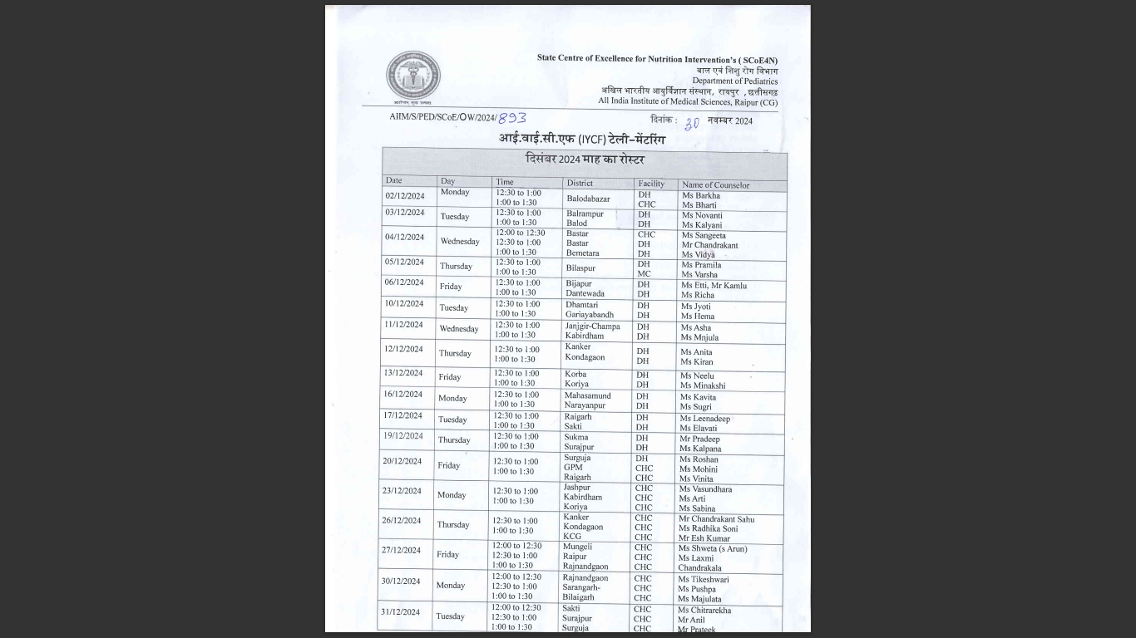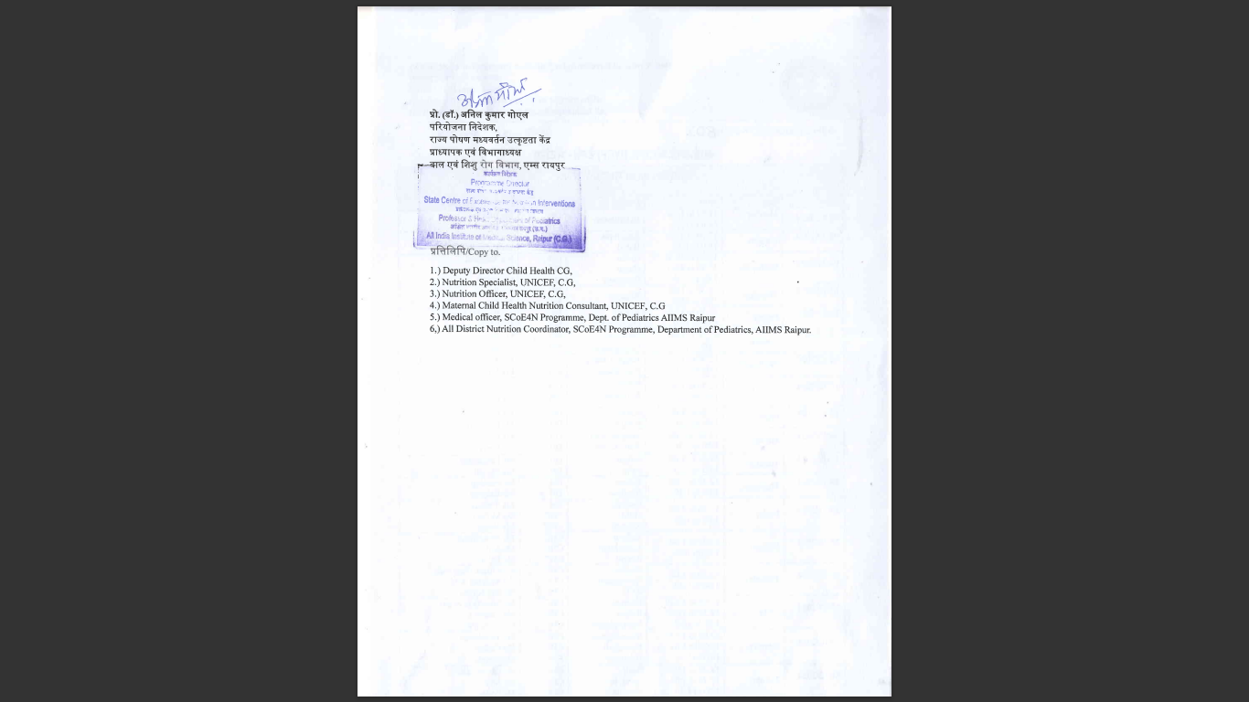

**प्रो. (डॉ.) अनिल कुमार गोएल**  
परियोजना निदेशक, राज्य पोषण मध्यवर्तन उत्कृष्टता केंद्र (SCoE4N)  
प्राध्यापक एवं विभागाध्यक्ष  
बाल एवं शिशु रोग विभाग, एम्स रायपुर